**IoT BASED SMART IRRIGATION SYSTEM USING SOIL MOISTURE SENSOR AND ESP8266 NodeMCU**

**INTRODUCTION:**

Agriculture plays a vital role in development of agricultural countries. However, its ecosystem control technology is still immature with low level of intelligence. These issues have been always hindering the development of the country. Most of the farmers use large portions of farming land and it becomes very difficult to reach and track each corner of large lands. Sometime there is a possibility of uneven water sprinkles. This result in the bad quality crops which further leads to financial losses. To overcome this and many other problems faced by the farmers, we propose an IoT based smart irrigation system to automate the complete irrigation process and also send the data to an app.

**SMART IRRIGATION SYSTEM:**

In this project, we are building an IoT based irrigation system which measures the Moisture, Temperature and Humidity level in the soil and automatically irrigates the water based on the conditions in the soil. This system includes a water pump which sprinkles the water based on the soil conditions. This system not only irrigate water based on the conditions of the soil, but also sends the data to an online app to keep track of the land condition.

This project uses a Soil moisture sensor and Humidity and temperature sensor to measure the moisture content in the soil and humidity and temperature level in the air. These data are sent to the microcontroller which processes and determines if the land is needed to be irrigated and makes the water pump to sprinkle water. When the moisture level is low in the soil and the temperature and humidity level in the air is high, the microcontroller makes the water to sprinkle using the water pump. It also sends the informations collected to an online app to keep track.

**WORKING:**

This project uses Soil moisture sensor module to measure the moisture level and DHT11 Humidity Temperature sensor to measure the temperature and humidity level in the air. ESP8266 NodeMCU is the microcontroller used in this project. The information about the moisture level, Temperature and humidity level are send to the NodeMCU which is then processed and the system determines whether the moisture level is low and whether is needed to be irrigated based on the informations it gained from the sensors. If the system determines if the conditions are not normal for a good land, the microcontroller send the signal to the water pump and makes it to sprinkle water to the farm. If the conditions are normal and temperature is normal in the air, the system does nothing and continues to monitor the condition of the soil and air. Even while sprinkling, the sensor continues to measure the conditions, if the soil moisture level reaches normal, the sprinkling is stopped. Blynk app is also used in the project, the informations and data collected from the sensor which are sent to the Microcontroller are sent to this cloud server, where the data are saved and kept track. These data can be used for future purposes

**CODING USED:**

#define BLYNK_PRINT Serial

#include <Wire.h>

#include <ESP8266WiFi.h>

#include <BlynkSimpleEsp8266.h>

// You should get Auth Token in the Blynk App.

// Go to the Project Settings (nut icon).

char auth[] = "uzGZVE19GOPZn5y_20EAixY0EDVCq-th";

// Your WiFi credentials.

// Set password to "" for open networks.

char ssid[] = "123456789";

char pass[] = "0987654321";

void setup()

{

  // Debug console

  Serial.begin(9600);

  Blynk.begin(auth, ssid, pass);

}

void loop()

{

  Blynk.run();

}

**CIRCUIT DIAGRAM:**

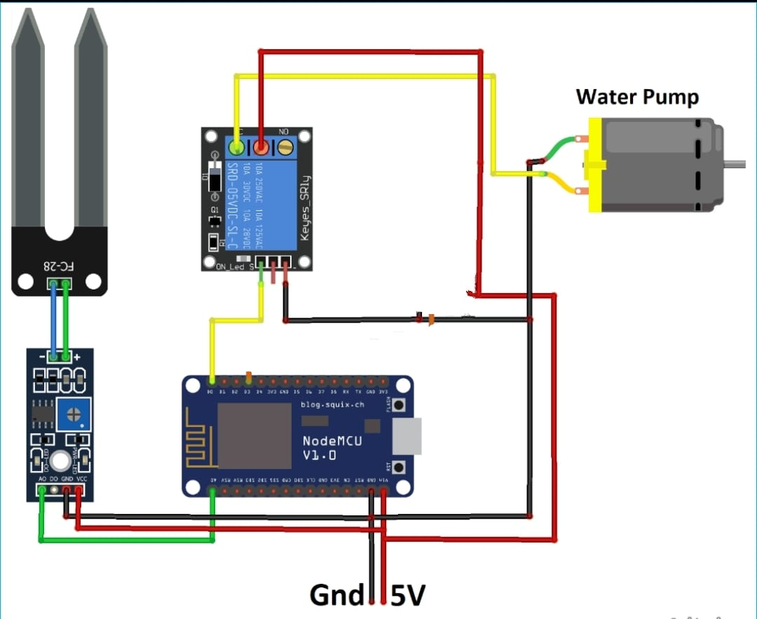

**PROJECT IMAGES:**

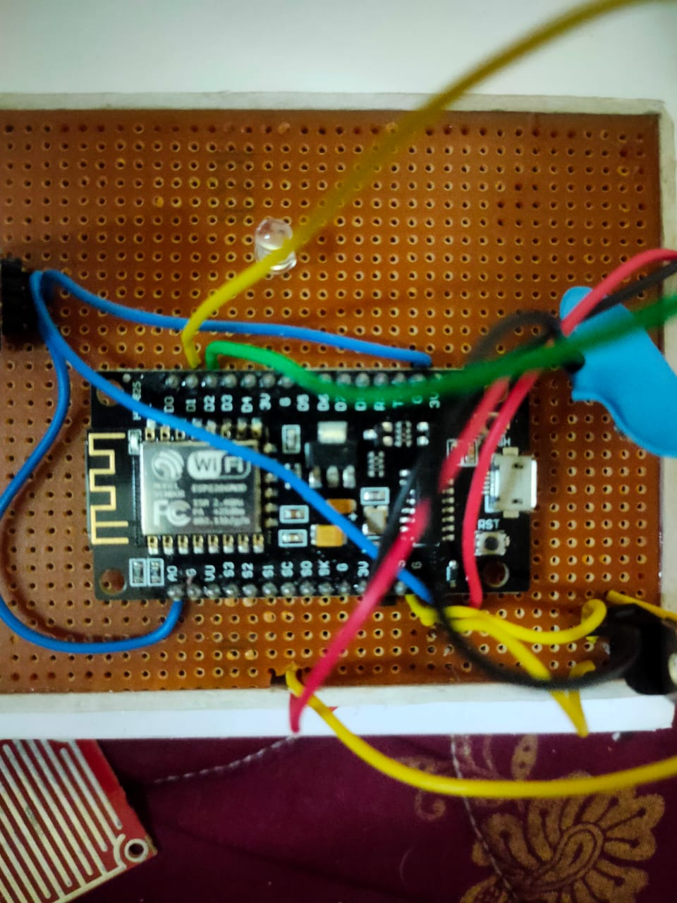

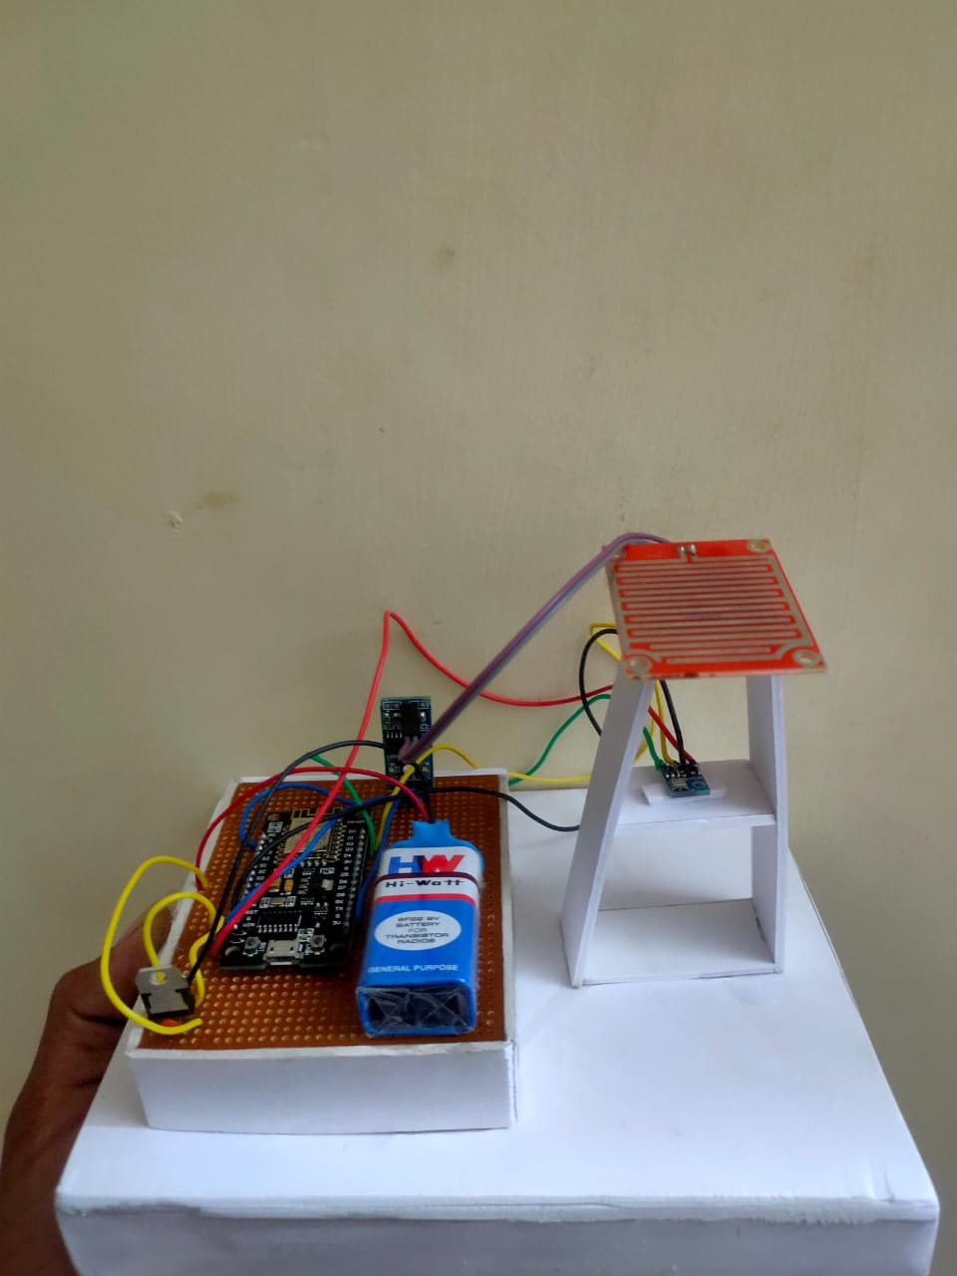

**RESULT:**

An ESP8266 Based automatic irrigation IoT system is proposed to modernization and improves the productivity of the crop. This project fills the limitations and problems faced by the farmers by sprinkling water evenly based on the requirement. It also sends the soil conditions to a webserver which can be used for future purpose.